**Spring Framework**

Features Of Spring :

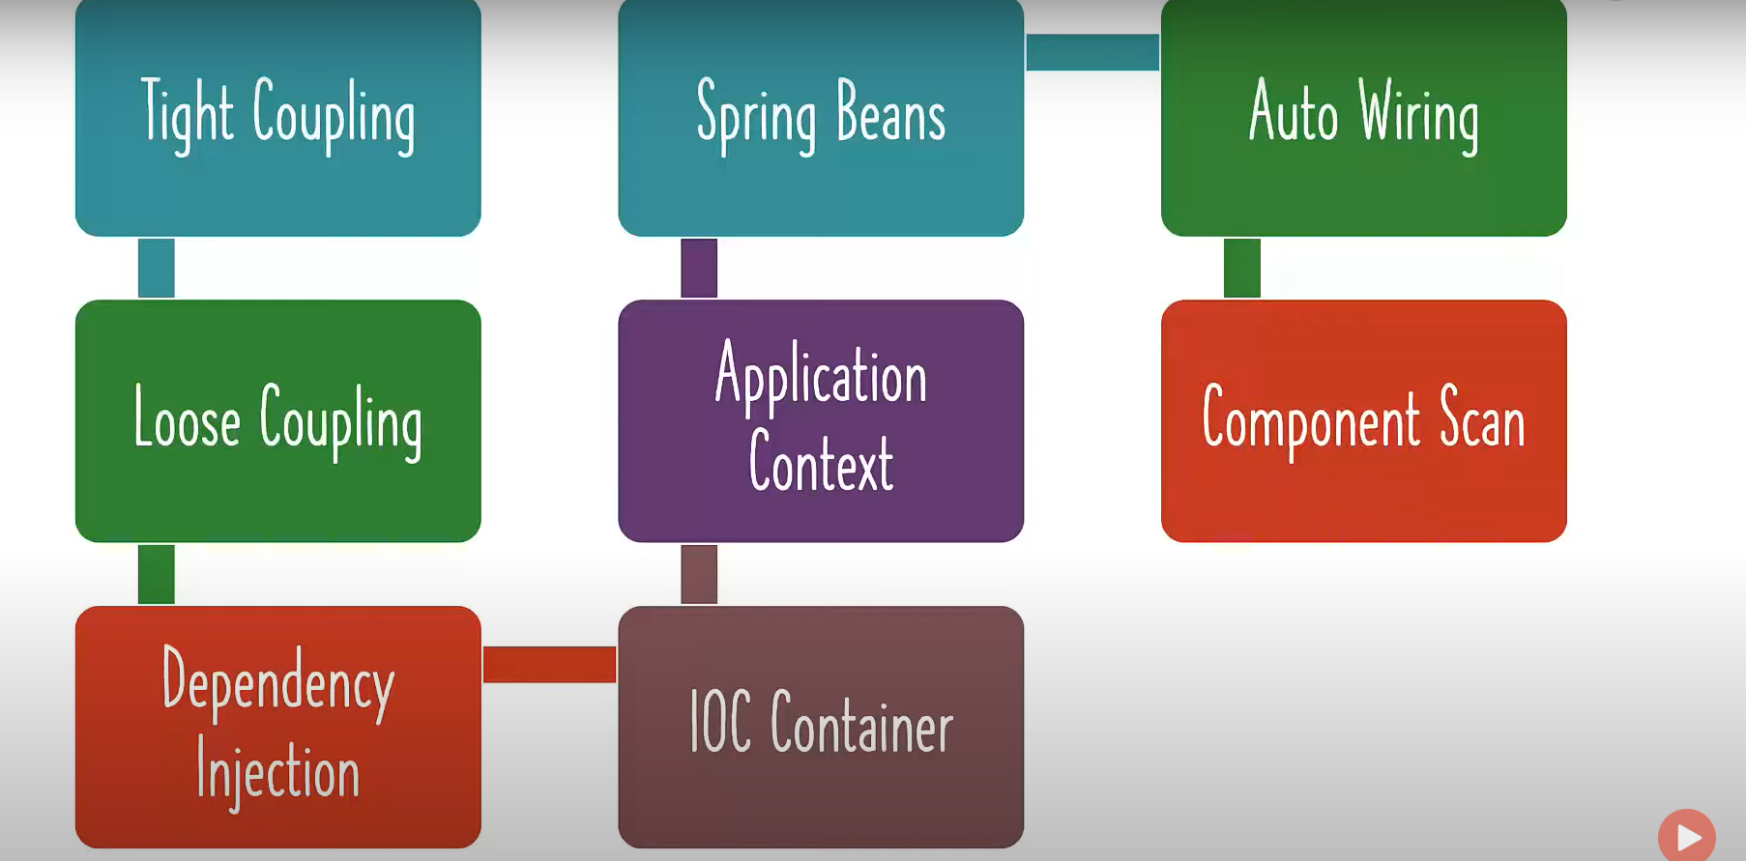

Why Spring ?

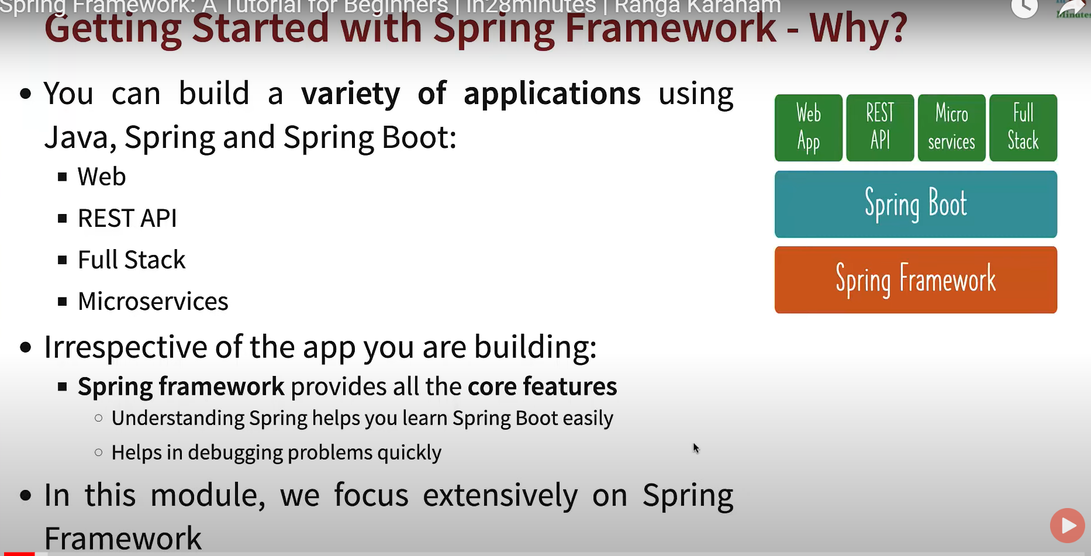

What is coupling ?

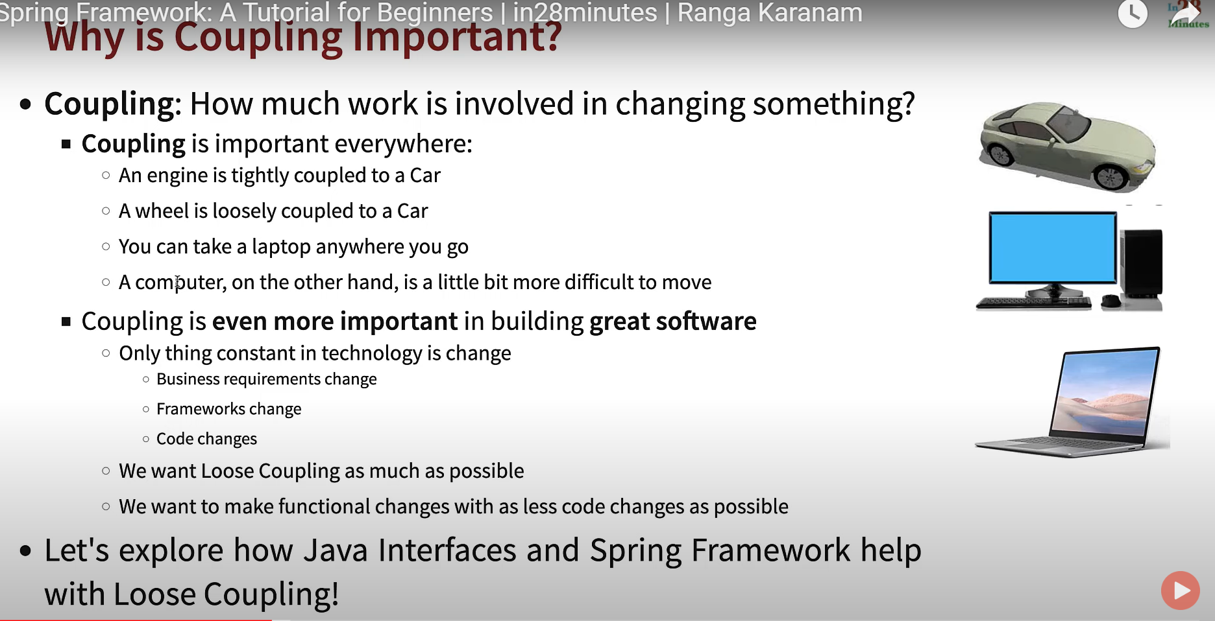

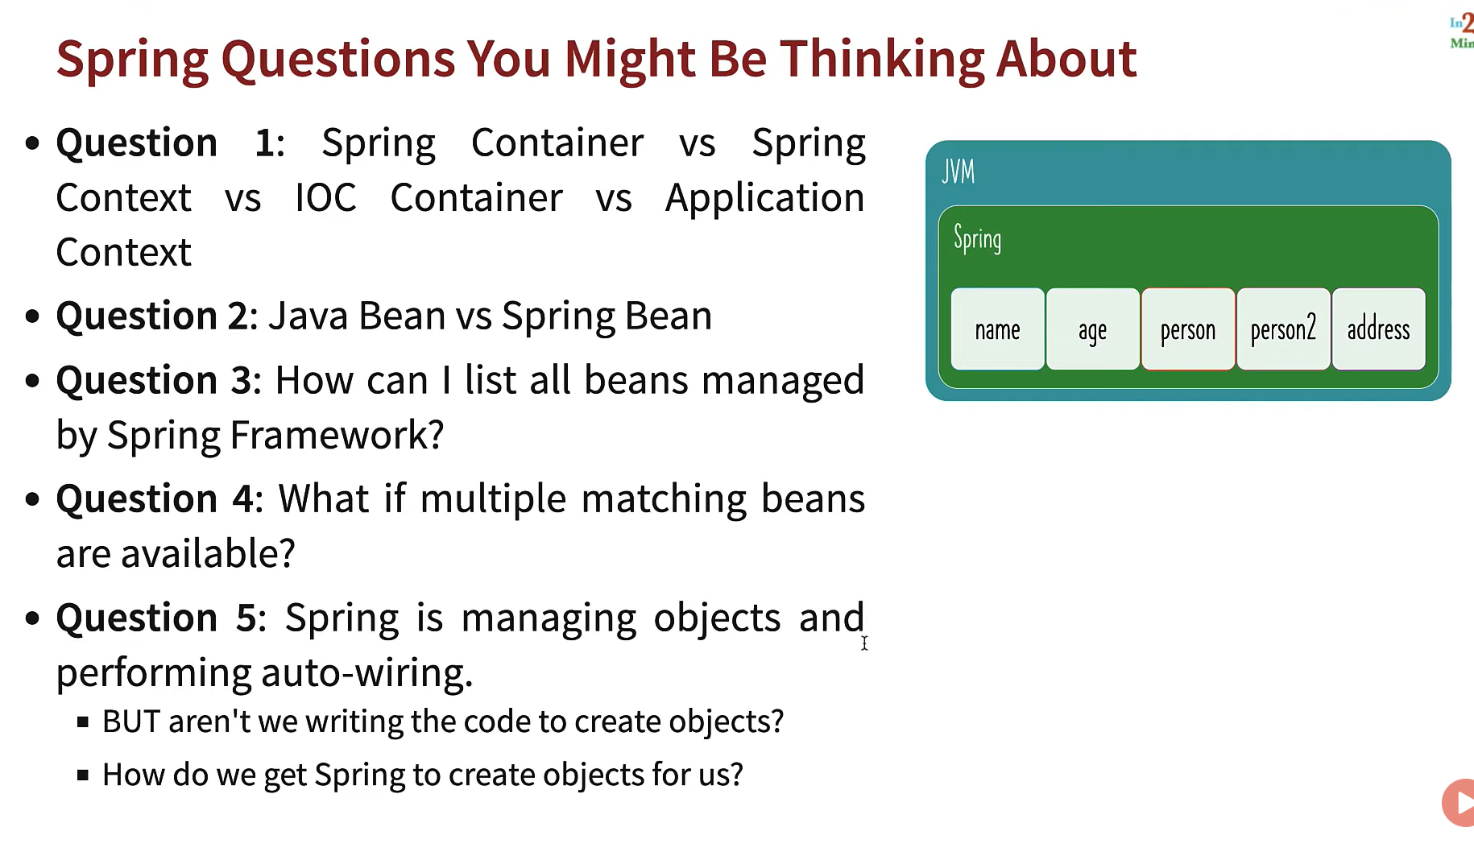

Question 3

Using getBeanDefinitionNames() - This method will return string array of beans names which is managed by the spring container.

Using AnnotationConfigApplicationContext.getbean(“bean name”) method we retrieve the value of the bean .

Question 4:

By using @primary and @Qualifier(Value = “name”) annotations we can make use of multiple beans with the same name .

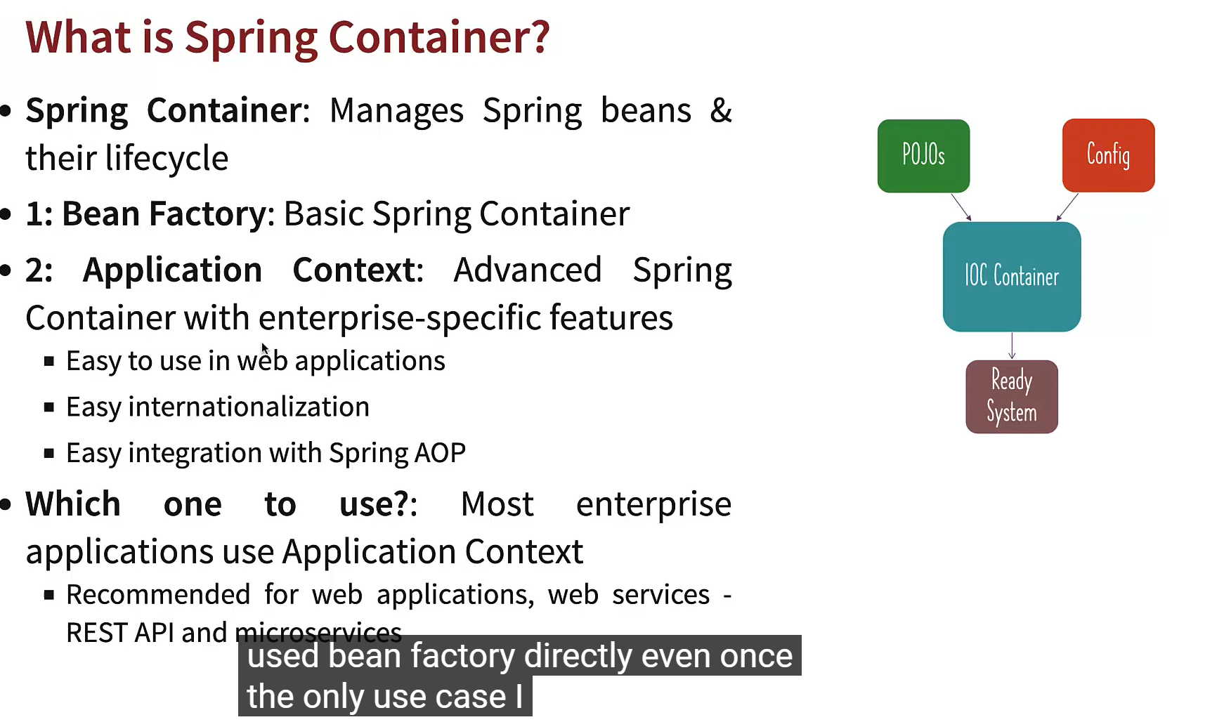

What is Spring Container ?

Spring container manages beans and their lifecycle .

Tyes of name for spring container

1. Spring container
2. Spring context
3. Soring IOC container

There are two type Spring container

1. Bean factory
2. Application context

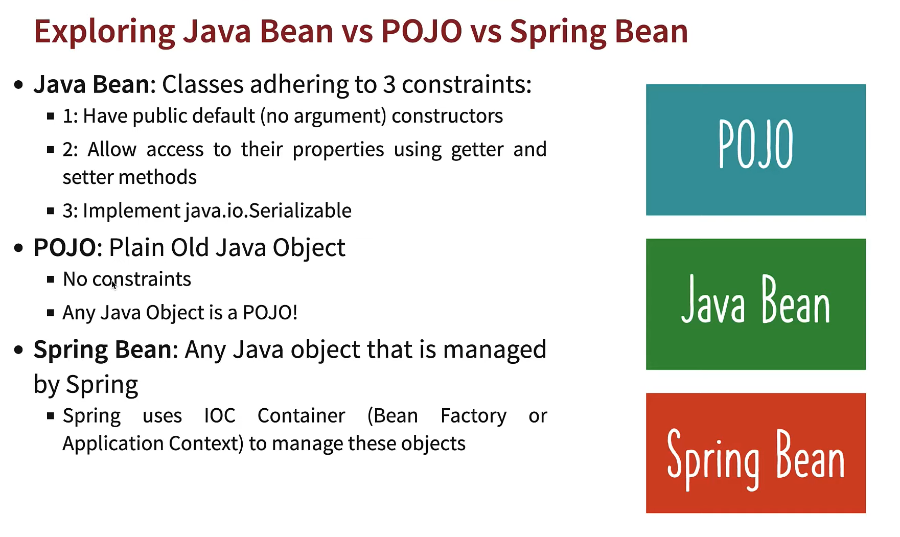

Concepts covered on day 1:

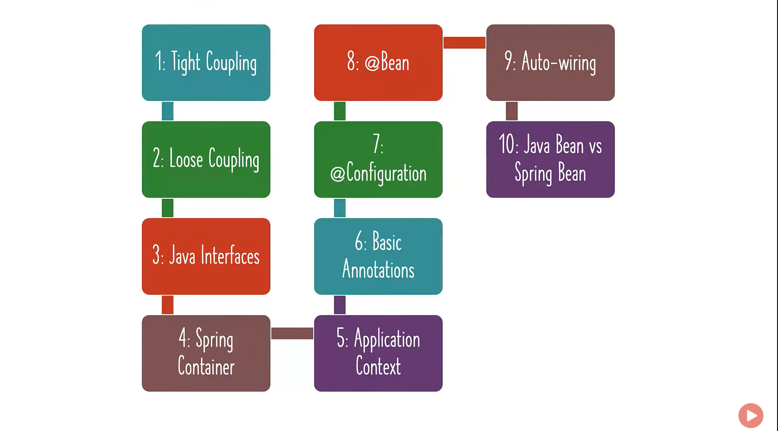

Concepts which java developer needs to know:

